Church Attendance Tracker Program (offline)
Setup and Configuration
Written by: Clifford Dela Cruz

Background
This system is designed for use within a church to efficiently track member attendance. It is intended to address several challenges faced by the ushers and the hospitality ministry, including:
- Accurate Record Keeping: Effectively capturing and storing attendance data for each service.
- Follow-up Identification: Easily identifying members who may require further follow-up or care.
- Data Integrity: Producing a clean, duplicate-free list of members for administrative use.

Packaging instructions:
- Make sure “attendance_tracking_program.py” and “Attendance Tracker.xlsx” are in the same folder
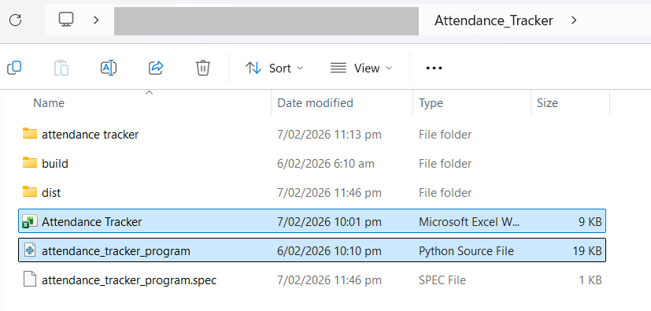
- Create a clean environment
conda create -n buildenv python=3.10
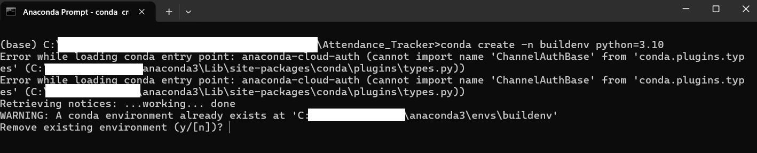

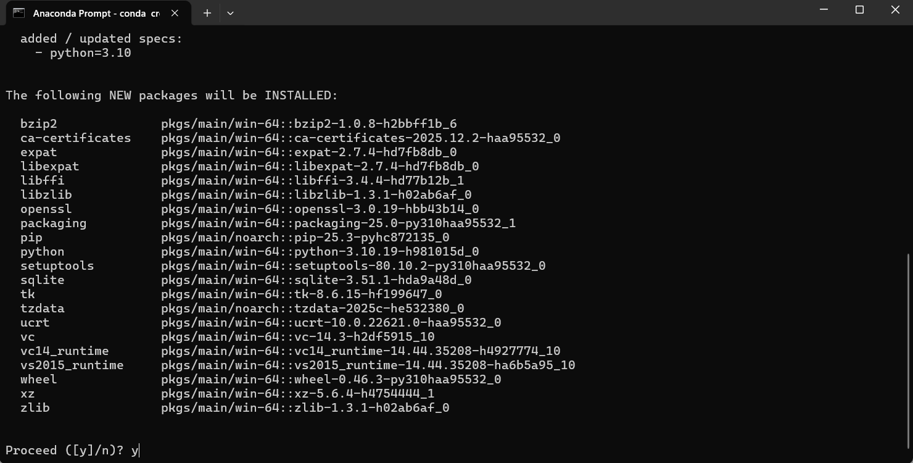
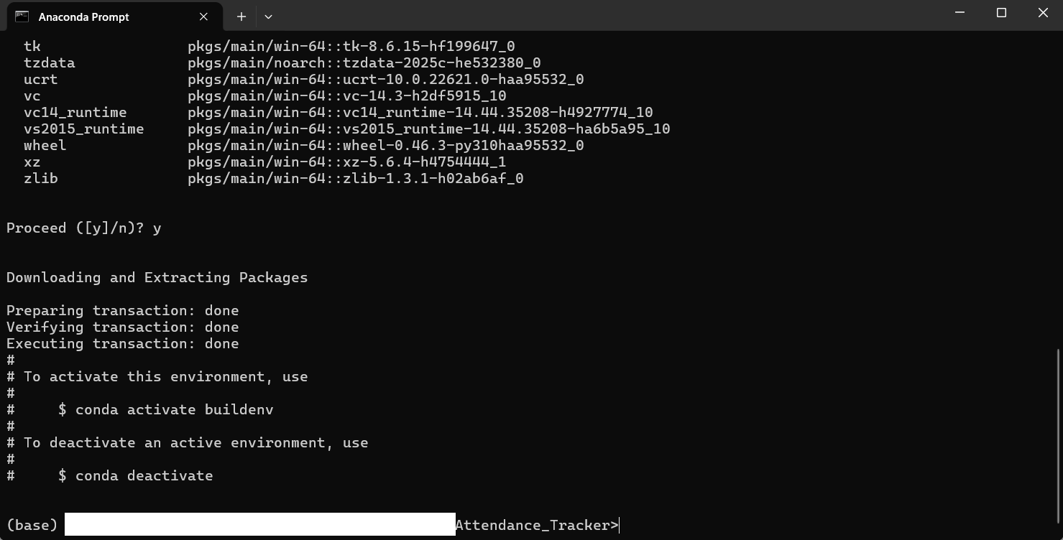
- Activate the new build environment.
conda activate buildenv

- Install only what the program needs:
pip install pyinstaller pandas openpyxl tkcalendar
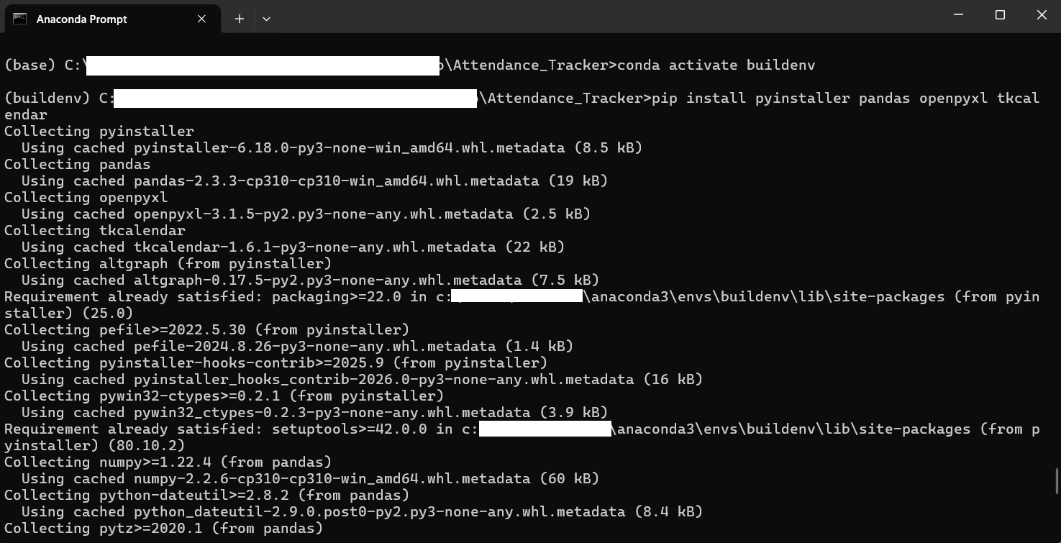

- Proceed to package
pyinstaller --onefile --windowed attendance_tracker_program.py
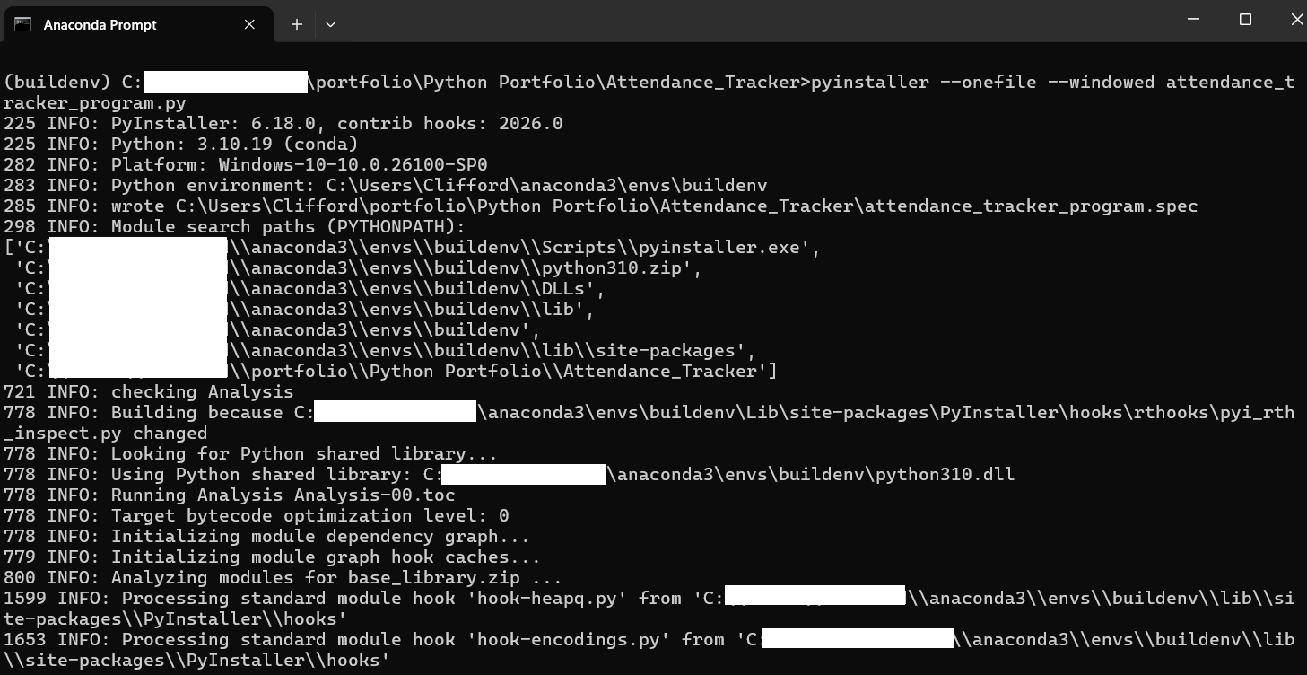

Check the file path and check if the executable program is in there
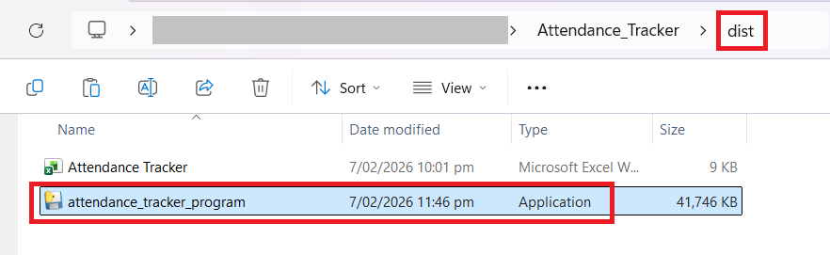

Things to take note:
- For “Attendance Tracker” spreadsheet
- “Person_Master” – stores the members non-sensitive information (name, cell group, ministry, if baptized, if attended discipleship class, if attended Bible literacy program, if attended Financial Literacy program, if attended teaching class and the last attended church service
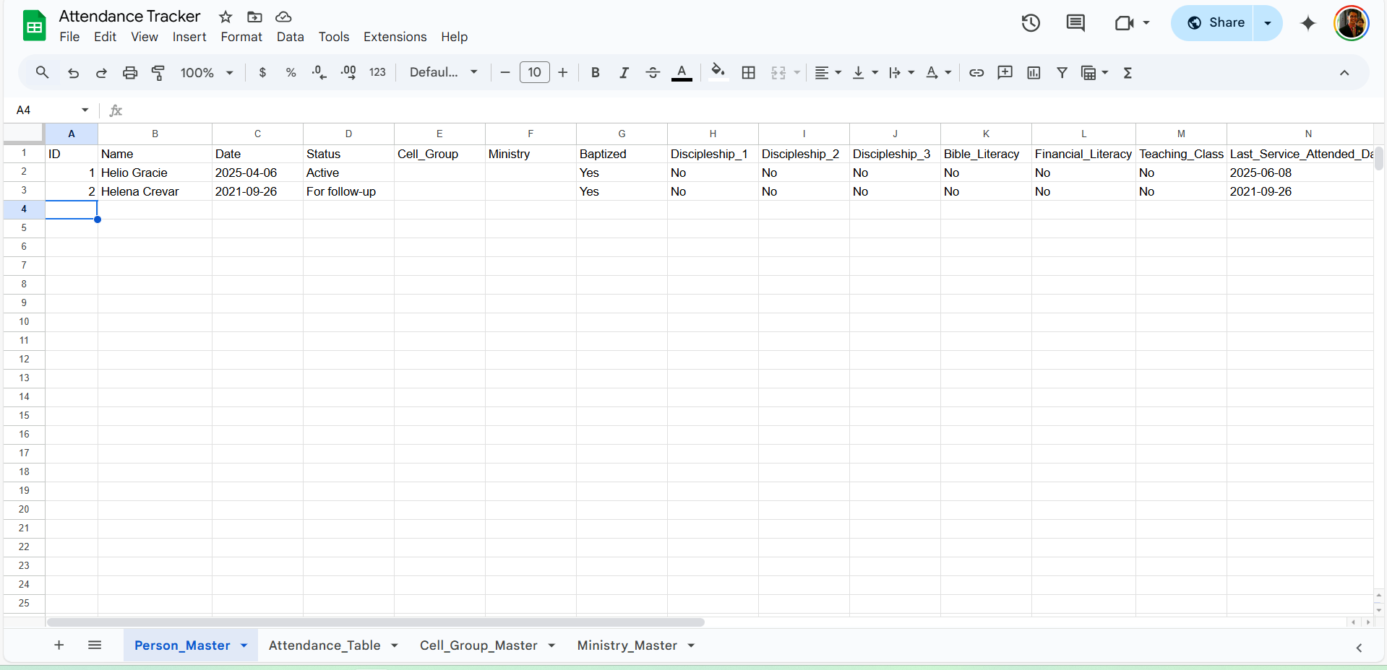
- “Attendance_Table” – stores member’s name and date attended
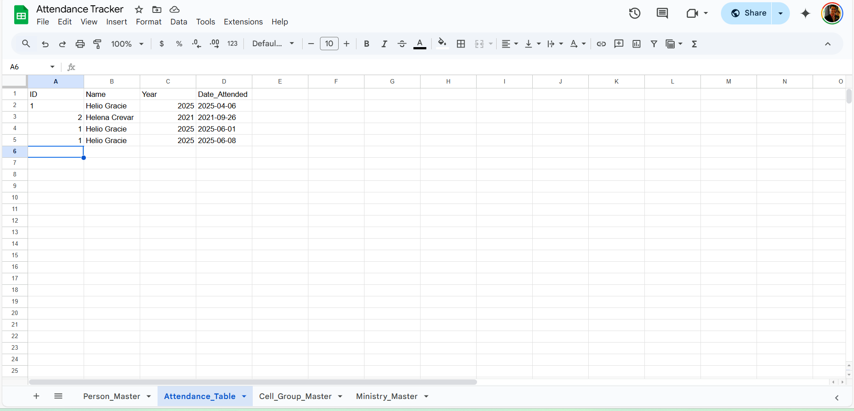
- “Cell_Group_Master” – contains cell group name and its PIC. This list is used to display data in “Cell Group” drop down list
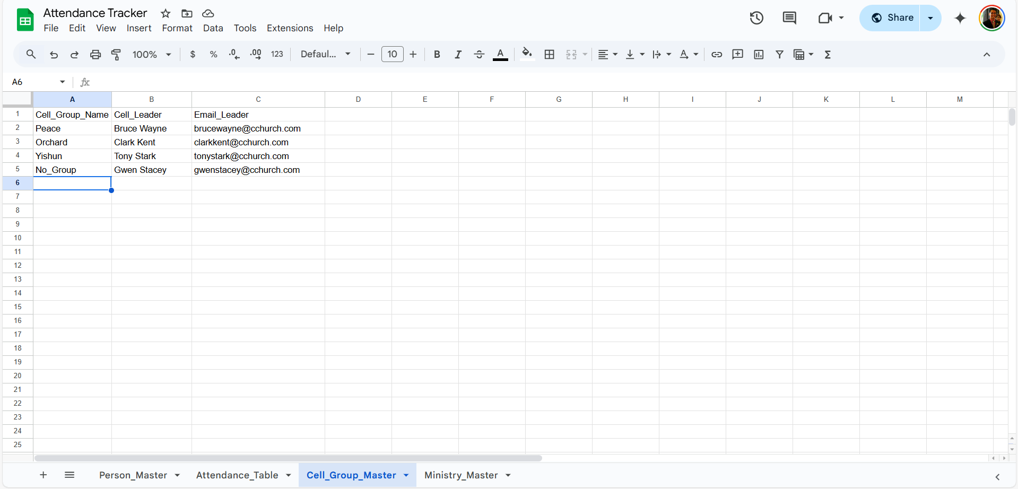
- “Ministry_Master” – contains ministry name and its PIC. This list is used to display data in “Ministry Master” drop down list
